**Heroes of Pymoli – An Analysis**

Heroes of Pymoli is the most recent fantasy video game.

The analysis of the Heroes of Pymoli is based upon data collected for 576 unique players out of which 84% are male, 14% are female and 2% are other/non-disclosed. For the purpose of this report, the numerical results have been rounded. The age of the players ranges from 7 yrs to 45 yrs. They have been categorized in bins of 5 years.

A total revenue of $2,380 was generated by 780 purchases made on 183 unique items. The average price was $3.05.

Although the male group generated the most revenue (this is probably because of the fact that they constitute majority of the players), the average purchase price for them was the lowest ($3.02) as compared to females ($3.20) and others ($3.35).

Majority of the players fell under the age group 20-24 (45% !) followed closely by age groups15-19 (19%) and 25-29 (13%). However, the people in age group 35-39 spent the most in per person purchase. This could probably be because they have more disposable income.

The Table 1 below lists the most popular items based upon the number of purchases and the Table 2 lists the most profitable items:

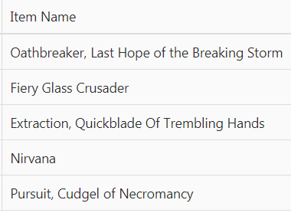 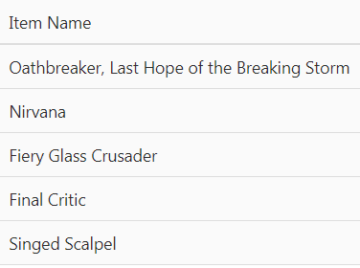

Table 1 Table 2

Oathbreaker, Last Hope of the Breaking Storm; Fiery Glass Crusader and Nirvana are definitely the winners based upon popularity as well as profitability.

Based upon the results, the game maker should come up with ideas to focus more on selling items to the males. From the results, it looks like they are happy with the free stuff and don’t spend much on extra items. They should also work on making the game more attractive to female players so they attract more female players as they spend more on average purchase.